DEVON BELLES  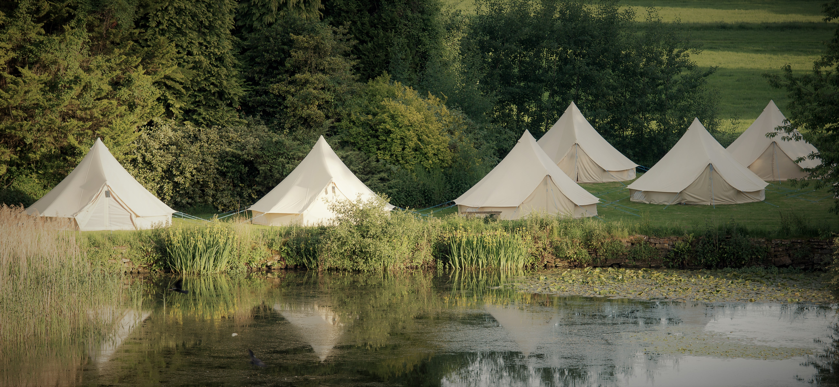  ~BELL TENT HIRE~  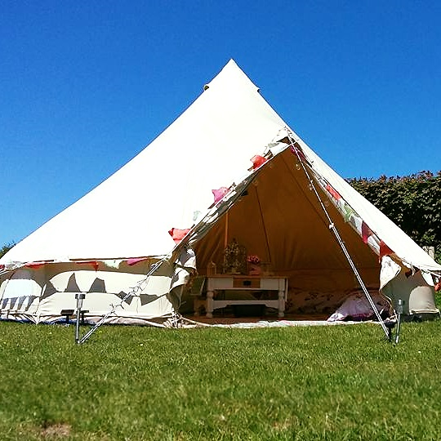  Available for the wedding of  Lucy & Jason  20th July 2019  Our beautiful 5m retro design bell tents are available for you to hire for the celebrations at Home Farm to mark  Lucy and Jason’s special day!  Our tents are available empty for you to bring your own bedding and comforts, or furnished and come with airbeds, bedding & bed linen already made up, 2 floor rugs, a low level table, vase of flowers  & a battery operated lantern.  The cost is as follows:  Empty tent: £129  Airbeds available to hire ready inflated at  £6 per single and £12 per double.  Furnished tent for 2 persons: £159  Please state whether you would like a double or 2 singles  Extra persons (single beds): £25 each. Max. of 6 persons per tent.  Towels £2.50 each. | Stay on site in a beautiful tent, all ready for your arrival!  ────  Choose between empty or furnished for minimal hassle!  Tents available to guests:  2pm Saturday 20th July  to  12 noon Sunday 21st  Closing date for bookings  20th June 2019  For more details or to book one of our tents to stay at Home Farm then please call Devon Belles on  079 8869 3747 or email: info@devonbelltent.com quoting Lucy & Jason’s wedding!

